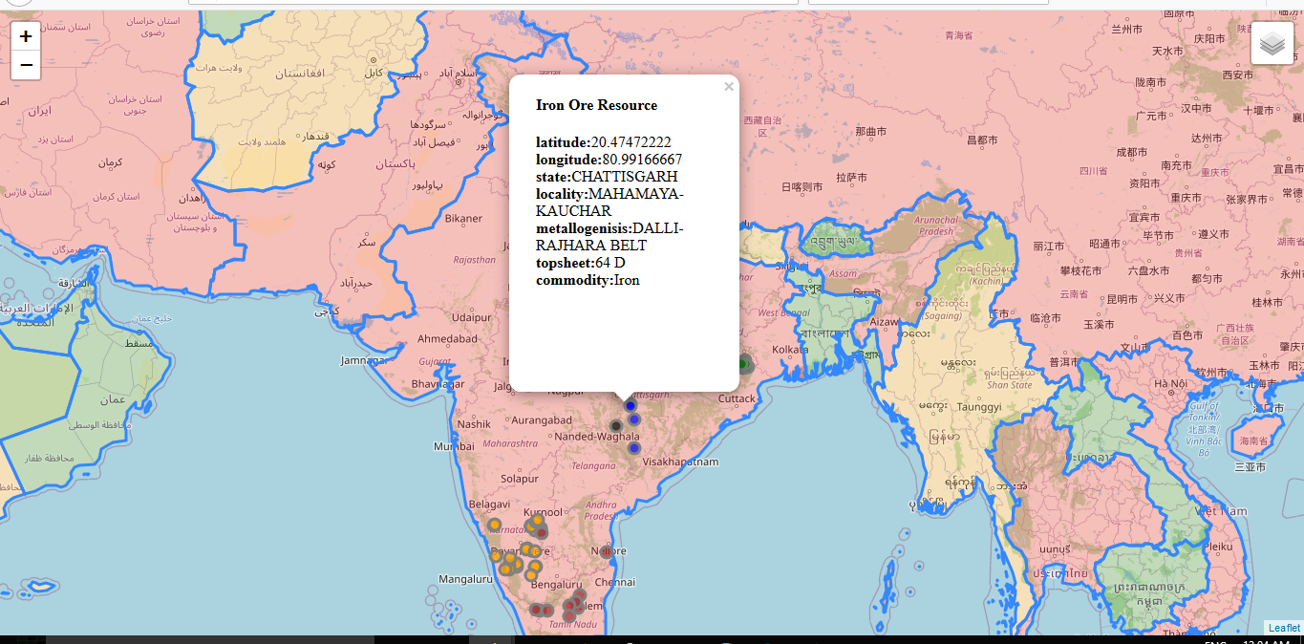

TCR INNOVATION

Gepgraphic data visualisation project of Iron ore in india

T. Rahul Naidu & T. Chandra Sekhar| Data Visualization| 07-11-2021

Mail-id:

[naidu.r1999@gmail.com](mailto:naidu.r1999@gmail.com)

chanduroxtar@gmail.com

-> This was the first end to end project that I made in my first week of learning python which got me hooked to the language. I was really impressed by the fact that we could make such visually impressive projects using such little lines of code by utilizing the pre-existing python packages.

-> The best part about this project is that we don’t need to install python or Jupyter/anaconda to run it. I have made it using google Collaboratory. In this project I have followed the complete pipeline of downloading data from a public website, reading packages, designing the map according to my use case.

# **Theme and purpose of the project:**

1)Using this project I wanted to show the major iron ore resource sites in India and their properties according to different states.

2)The project also has a selection called population which shows country having population above 50 million in red, between 20 to 50 million in orange and less than 20 million in green.

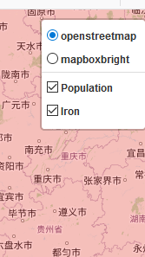

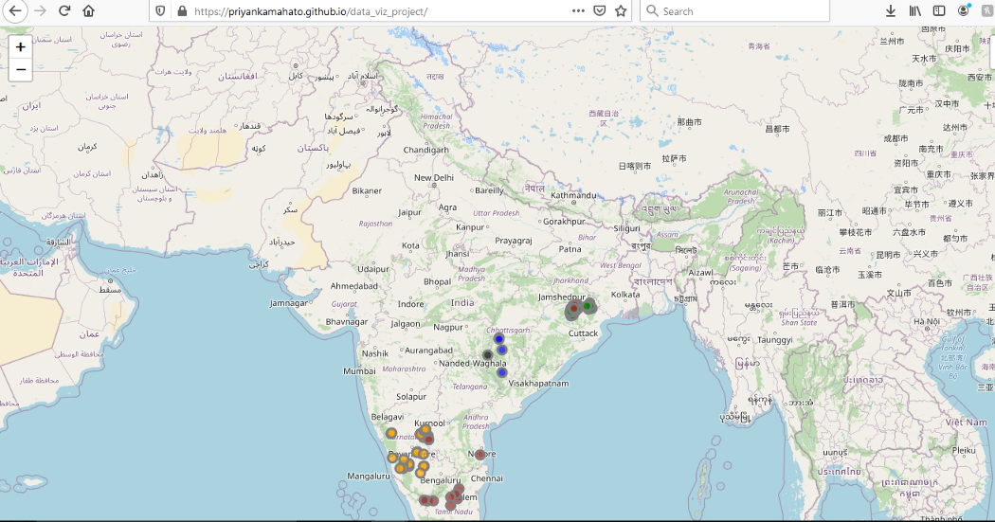

# Two Major Steps of the Project:

1.Downloading the data from the respective data sources

2.Writing the code for map feature in the google Collab notebook

# **Detailed Explanation of the steps:**

Step 1:

1.There are two data files that are required for the project

2.The first one is downloaded from data.gov.in which is a csv file having details about iron ore resources in India.

3.The second file is a json file having metrics such as country name and population

## **Step 2 - Code Walk Through:**

Here I will be explaining the steps I followed to write the code of the project

1. **Installing packages**- Packages used in the project are folium and pandas The general format of installing packages in google collab is! pip install library name. So, to install folium and pandas’ type

## **What is folium**

Folium is a python package that can be used to make beautiful, interactive maps. Folium makes it easy to visualize data that’s been manipulated in Python on an interactive Leaflet map.

Folium has a number of built-in tile sets from OpenStreetMap, MapQuest Open, MapQuest Open Aerial, Map box, and Stamen, and supports custom tile sets with Map box or Cloud made API key

2. Next we would need to import the packages, read files from the local system to google collab, read data into pandas df and display the top 5 rows of the data frame.

3. Browse to open the Iron_Ore_1.csv file.

4.Basic Exploratory Data Analysis Performed to get the data types, column names and unique value of states in the data frame.

5.Storing columns in the form of a python list.

6. Create the base layer of the map.

7. Setting up different color of markers for different states.

8. Creating the Iron ore layer, adding the markers and popup in specific latitude and longitude locations.

9. Upload the world .json file

10. Creating the population feature group, adding both the iron ore layer and population layer to the map and saving the map in the form of an html doc.